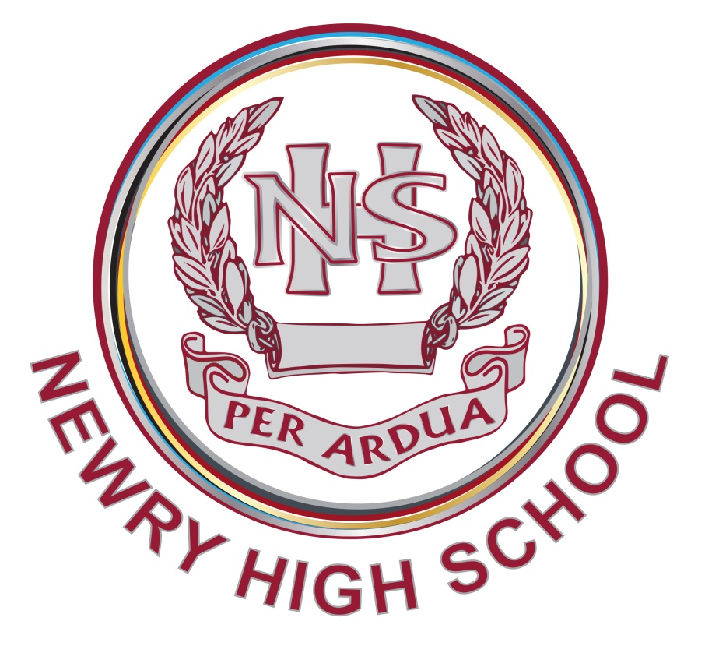

Title | Smoke/Vape Free Policy
Summary | This policy sets out our commitment to ensure all procedures are followed regarding the internal assessment arrangements regarding controlled assesments
Purpose | To ensure that each department carries out controlled assessments in accordance with the instructions issued by the Joint Council for Qualifications (JCQ)
Operational Date | September 2023
Frequency of Review | Every 3 years
Date last Reviewed and Approved by Board of Governors | April 2023
Smoke/Vape
Free Policy
Introduction

It is the policy of Newry High School that all of our workplaces are smoke/vape free and all pupils/members of staff have a right to work in a smoke/vape free environment. Smoking/vaping is prohibited throughout the entire school with no exceptions. This policy covers both nicotine and other substances which can be smoked/vaped.

Statement of intent and rationale

Newry High School has a duty to protect its employees and students from known hazards. We understand that the health risks associated with smoking are serious and detrimental for those who smoke, as well as people within close proximity. Although e-cigarettes are not covered by the Health Act 2006, the school adopts a fully smoke-free environment, and recognises that use of e-cigarettes, still pose some hazards, particularly for those with asthma and respiratory conditions who may be affected by the vapour. In addition, we take seriously our duty to promote children and young people’s wellbeing and their spiritual, moral, social and cultural development. We see our commitment to creating a smoke/vape free environment and developing pupil’s knowledge, attitudes and skills in decision making around smoking/vaping as part of our work on keeping children and studentssafe around drugs and managing risk.

Aim

The aim of this policy is to ensure a whole-school approach to smoking/vaping in order to protect all members of the school community from the harms of second-hand smoke and to prevent the uptake of, and reduce the prevalence of, smoking/vaping across the school community.

Objectives

- To create a smoke-free environment for all those within the school community, including staff, students, visitors, parents, carers, etc.
- To clarify the the consqunces of non-complaince
- To ensure that the school’s smoke free/vape free policy is applied when students are taken off site.
- To ensure that smoking/vaping education is part of the school’s preventative curriculum/PSE
- To involve all staff, governors, pupils, parents/carers and members of the wider school community including outside agencies as appropriate, in the development of policy and practice in relation to smoking /vaping.
- To provide assistance for pupils, staff and other members of the school community who smoke/vape and wish to stop.

Legal framework

This policy has due regard to legislation, including, but not limited to, the following:
- Health and Safety at Work etc. Act 1974
- Health Act 2006
- Children and Young Persons (Protection from Tobacco) Act 1991
- Nicotine Inhaling Products (Age of Sale and Proxy Purchasing) Regulations 2015
- Equality Act 2010

This policy also has due regard to guidance including, but not limited to, the following:

- Public Health England (2016) ‘Use of e-cigarettes in public places and workplaces’

This policy will be implemented in conjunction with the School’s:
- Pastoral Care policy
- Drug Policy
- Health and Safety Policy
- Postive Behaviour Policy
- Educational Visits Policy
- Staff Disciplinary Policy
- Searching and Confiscation Policy
- Safegauarding policy

Providing a smoke free environment

- This policy applies to students, staff, parents/carers, members of the public, contractors or others working / using the school premises or vehicles and all vehicles used to transport students.
- Smoking/vaping is not permitted in any part of the school’s premises and grounds including the entrance area to the school, on land adjacent to the school building (e.g. car parks, grass areas etc).
- There are no designated smoking/vaping areas provided within the school buildings or grounds.
- The smoke free/vape free policy applies to all events / activities held in the school including before and after school sessions, any meetings organised which are attended by school employees as part of their work and/or visitors to such meetings/events.
- This policy applies when students are taken off site on school excursions/ visits/trips. Staff and accompanying helpers will be reminded that smoking/vaping is not permitted when on duty / looking after students.

Smoking/Vaping prevention activities

- Students are not permitted to smoke/vape when in uniform or when representing the school in any capacity. This includes all tobacco products and electronic (e) cigarettes.
- Employees are not permitted to smoke/vape in the view of pupils. Employees who do smoke/vape will be asked to ensure they cannot be seen smoking/vaping by students (even if it is off the school grounds).
- Smoking/vaping education is part of the School’s prevettive curriculum of drug education / PSE (including the health effects, legal, economic and social aspects of tobacco/vape use) which may be delivered across the curriculum
- A range of age appropriate methodologies will be used to deliver tobacco/vaping education with the aim of preventing the uptake of smoking/vaping The school supports smoking/vaping education through the transition phase from primary to secondary school.
- Parents/carers are encouraged and supported to be actively involved in their child’s drug/tobacco/vaping education through home/school activities, education evenings etc.

Procedures for non-compliance with the smoke free policy

Staff

The Schools Disciplinary Procedure will be followed for members of staff who do not comply with the school’s smoke/vape free policy.

The staff member will be offered support to help them quit smoking through linking them with appropriate support in the community.

Students

Students will be classed as smoking or vaping if:

- They are seen smoking or vaping.
- They are seen with a lit cigarette or e-cigarette in their hand.
- They are found to have cigarettes, an e-cigarette or other smoking materials in their possession.
- They are seen repeatedly in the company of others who are smoking or vaping.

The following procedure will be followed for students in breach of the school’s smoke/vape free policy:

Any pupil caught vaping / smoking or found in possession of a vape, liquid, cigarettes, lighter or other smoking related items in school will automatically be suspended for a minimum of 1 day.

For repeat offenders, this suspension is likely to be extended and will be followed up with preventative measures in school e.g. detention / supervision at break & lunch. In addition, the names of persistent offenders will be communicated to the PSNI.

The school may choose to seek assistance from the Local Council Enforcement Officer or the Police in pursuing a statutory fixed penalty notice. The penalties and fines for the smoke-free offences set out in Health Act 2006 are:

- smoking in smoke-free premises,: a fixed penalty notice of £50 (reduced to £30 if paid in 15 days) for the person smoking, or a maximum fine of £1,000 if prosecuted and convicted by a court

- an adult buying, or attempting to buy, tobacco products or nicotine inhaling products (including e-cigarettes/ vapes) on behalf of a person under the age of 18: a fixed penalty notice of £250, or a maximum fine of £5,000 if prosecuted and convicted by a court

Non staff members/school visitors

Staff are authorised to ask non-employees who breach the policy to adhere to the policy.

Assistance for those who smoke

The school aims to implement effective, supportive procedures for those who want to quit smoking, and improve the health of both smokers and non-smokers. The school regularly educates the students about the effects of smoking, both through the requirements of the national curriculum, and through additional sessions, e.g. PSE lessons and assemblies. The student are encouraged to seek help from other professionals about the effects of smoking, if they would like to quit smoking, or would like to know more about additional methods of support.

Students, can also access services through the school nursing service, their GP Practice, local pharmacy or by contacting the NHS Specialist Stop Smoking Service on stop.smoking@southerntrust.hscni.net or 028 3756 4400

