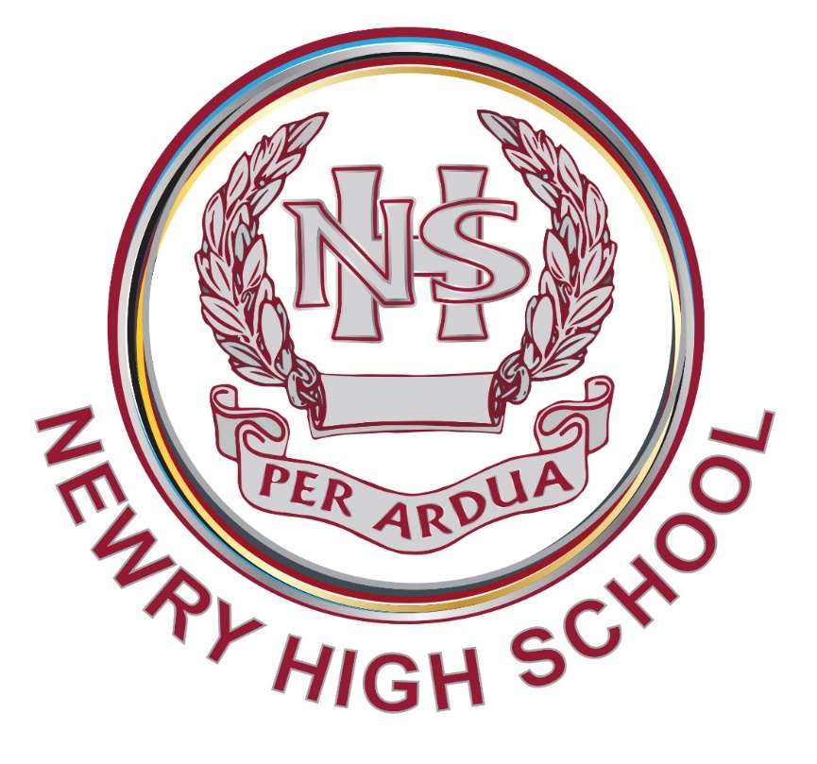

# **Period Dignity Policy**

| **Title** | **Period Dignity Policy** |
| --- | --- |
| **Summary** | To ensure that pupils, staff, and parents/carers understand the term ‘period dignity’ |
| **Purpose** | To ensure free accessibility to period products, menstrual education and the de-stigmatisation surrounding menstruation. |
| **Operational Date** | September 2024 |
| **Frequency of Review** | Every 3 Years |
| **Date last Reviewed and Approved by Board of Governors** | September 2024 |

1. **Introduction**

We believe the success of our students is in part based upon the school aims and shared values. We are committed to providing an excellent standard of education for all students, whatever their ability or background. We aim to foster the all-round development of each individual, so that everyone can make the most of their talents and contribute to the life of the school and the wider community. Our approach to Teaching and Learning is based upon high expectations and positive relationships which show mutual respect, trust and a desire to achieve the very best.

We aim for Newry High School to be a purposeful and happy place where everyone is actively engaged in, and stimulated by, the process of learning. We want to demonstrate awareness that students all learn in a variety of ways and that learning is a lifelong experience. We want to empower young people to achieve their potential and to make informed and responsible decisions throughout their lives.

The objectives are to develop the young person as:

* an individual
* a contributor to society and
* a contributor to the economy and environment

Our overarching aim is to provide an inclusive and diverse curriculum which is balanced, broad, relevant and appropriate.

The curriculum will:

* promote the spiritual, moral, cultural, mental and physical development of students.
* prepare students for the opportunities, responsibilities and experiences of adult life.
* actively challenge each pupil ensuring all students reach their full potential.

Newry High School aims to promote academic excellence and the personal development of every student in a safe and nurturing environment which is responsive to individual needs, aspirations, and talents. We actively promote the value and importance of physical and emotional health and wellbeing and equip all with the skills, guidance, and confidence to make a successful transition to adult life to meet the demands of a competitive and changing world

We recognise that many pupils may have additional physical, emotional, mental, social and educational needs due to the challenges and difficulties surrounding menstruation which may, at times, create barriers to learning. In implementing this policy, we believe that pupils can be helped to overcome these barriers to learning and be supported to reach their full potential.

A whole school approach is adopted in relation to period dignity issues and is linked to our pastoral priorities within our School Development Plan through the development of a preventative curriculum at Key Stages 3, 4 & 5 to meet the needs of all our pupils.

The implementation of the Period Dignity Scheme at Newry High School sits within the Preventative Curriculum and enables the topic of menstruation to be addressed and openly discussed so that our young people are equipped with the skills, attitudes and behaviours to recognise, understand and respect the different challenges and difficulties that people may experience when menstruating, irrespective of religious belief, race, disability, age or sexual orientation.

All staff, teaching and non-teaching, should be aware of the importance of promoting period dignity. Staff are asked to be sensitively alert to signs of physical and emotional distress that a young person may be experiencing in relation to menstruation; for example, discomfort, pain, lack of concentration, leaking, anxiety or being unable to sit still while in class. Staff will manage such situations sensitively in line with our school values and ethos by helping the pupil to manage the situation themselves or by signposting them to a member of the Pastoral Care Team to access, for example, a change of clothing or safe, quiet space.

This policy sets out the procedures in place to ensure free accessibility to period products, menstrual education and the de-stigmatisation surrounding menstruation which will subsequently have a positive impact on pupil confidence, wellbeing, attendance and attainment.

1. **Aim and Objectives**

Our overarching aim within this policy is to have a positive impact on pupil confidence, wellbeing, attendance, and attainment. The aim will be met through the following objectives which ensure that pupils, staff, and parents/carers understand the term ‘period dignity’:

* raise awareness of the toxic trio* and how this impacts children and young people.
* promote period dignity in school and ensure that everyone who needs them has free access to period products.
* ensure that all pupils, staff, and parents/guardians understand the impact of periods on the physical, emotional, mental, social and educational wellbeing of pupils.
* enable learners to achieve their potential by reducing any barriers they may
* experience due to periods.
* reduce stigma/taboo in relation to periods by providing all pupils with relevant, age-appropriate information on periods so that a culture of openness in relation to
* menstrual issues are created.
* enable learners to understand how to deal with period issues, hygiene and disposal of period products.
* promote respect, understanding and open discussion about the challenges and
* difficulties that people may experience when menstruating.

*Toxic Trio refers to inaccessibility/unaffordability of period products, a lack of menstrual education, and period stigma.

1. **Whole School Approach**

Educating pupils on period dignity is the responsibility of all staff. In drawing up an

implementation plan, we have sought to ensure a whole school approach which visibly supports the promotion of period dignity using presentations by the Period Dignity Led to teaching and non-teaching staff, via Year Group Assemblies, and placing posters around the school, by working closely with the School Council and by means of a letter to parents via InTouch.

At Newry High School will encourage our parents to work in partnership with us by talking to their children about period dignity and menstrual wellbeing.

Relationships and Sexuality Education/Preventative Curriculum are statutory components of the Northern Ireland Curriculum, and it is within these areas that Period Dignity and menstrual wellbeing will be primarily addressed. However, parents/guardians have the right to have their child educated in accordance with their wishes, therefore the school will respect the requests of parents/guardians who wish to withdraw their child from Period Dignity and Menstrual Wellbeing education.

1. **Curricular Links**

The Period Dignity scheme sits firmly within our Pastoral Care programme, it will be

promoted and discussed at Key Stage 3 under the concept of Relationships & Sexuality and at Key Stages 4 & 5 under Personal Health & Wellbeing within our Preventative Curriculum. Menstruation will also be addressed in Science in Year 8 in the delivery of the Reproduction Unit of work and in Single Award Biology – Year 11.

We recognise that menstruation can be a sensitive topic for some people to talk about, and that in discussing menstruation and menstrual health other related sensitive topics may be brought up by participants (including gender identity, sexual health, contraception and pregnancy). Appropriate sensitivity when approaching these topics will be of paramount importance and handling questions and disclosures will be in line with our school’s Child Protection and Safeguarding Policy.

In line with our Equality and Inclusion Policy, for those pupils with sensory difficulties,

anxiety or autism spectrum disorder (ASD) or other learning difficulties, we will

adapt the pastoral or curricular lesson(s) accordingly to meet their individual needs

and recognise that education about periods may need to be delivered one to one. We will also be mindful of individual’s needs such as word triggers and the impact they can have.

Our overarching aim in educating pupils within the Pastoral Programme is to challenge negative views, stereotypes, gender inequality and stigma in line with our school’s Promoting Positive Behaviour Policy and Anti-Bullying Policy.

Guidance issued from NHS, CCEA and in DE Circulars will inform curricular planning to ensure relevance. This policy takes account of The Equality Act (Sexual Orientation) Regulations (Northern Ireland) 2006 and the relevant sections of UNCRC, available at [www.unicef.org.uk](http://www.unicef.org.uk). It also supports the Children and Young People’s Strategy for Northern Ireland.

This policy responds and relates to the following policies available either on the school website or available on request from the school reception:

* NHS Child Protection and Safeguarding Policy
* NHS Pastoral Care Policy
* NHS RSE policy (Currently being reviewed)
* NHS SEN policy
* NHS Promoting Positive Behaviour Policy
* NHS Anti-Bullying Policy

1. **Teaching Approaches/Strategies**

In delivering the Period Dignity aspect of the Pastoral Programme we will use active and experiential approaches when exploring issues around menstrual wellbeing.

Teaching of period dignity and menstrual wellbeing will be incorporated into the curriculum on an ongoing basis, building on knowledge and understanding, rather than being treated as a one-off lesson. The issues relating to periods, menstrual wellbeing and period dignity will form part of our Preventative Curriculum within each Year Group as it is integral to the physical, spiritual, emotional, moral, social and intellectual development of our pupils.

External organisations/agencies may be used to complement the delivery of elements of the Preventative Curriculum relating to Period Dignity and Menstrual Wellbeing. Where external agencies are involved, appropriate vetting procedures will be followed.

The normal teaching arrangements of mixed gender classes will remain in place for delivery of period dignity and menstrual education with the aim of increasing understanding among all pupils and to challenge/reduce stigma, myths and stereotypes. This arrangement will be kept under review. There will also be gender specific assemblies, carefully tailored to relate to different year groups.

Having open conversations with pupils of all genders will enable us to break down the stigma around periods, and work to prevent bullying and shaming behaviour. In Newry High School we seek to develop open conversations through menstrual education being delivered via mixed classes of boys and girls when period dignity is discussed in pastoral or curricular lessons. Staff will be mindful of cultural differences that may exist, for example, some cultures may be against the use of tampons. The Period Dignity Lead will remind staff to be mindful of their use of language when discussing periods in situations where there are pupils who identify as gender neutral.

As the Period Dignity Policy rolls out, we will continue to consult with our School Council to continue to improve and develop the policy on an ongoing basis.

1. **Resources**

Resources will be carefully selected to the age and learning needs of the pupils. Resources used, including images, videos and language will not include inappropriate or explicit content. All resources will be reviewed and quality assured by the Period Dignity Lead and/or those delivering the Preventative Curriculum to ensure that they are inclusive and consistent with the ethos and values of Newry High School as well as ensuring that they are factually accurate and up to date.

The resources used in the Pastoral/Preventative Curriculum will be those recommended or produced by CCEA. These resources will address the following key topics and themes:

* Key facts about the menstrual cycle.
* What is and isn’t normal.
* Communication skills needed to ask for help.
* The range of period products available, how and when they’re used, and their advantages and disadvantages.
* Menstrual wellness – physical, emotional and psychological wellbeing leading up to and during periods.
* Menstrual hygiene – essential facts and how to deal with related situations.
* Challenges – pain, anxiety, fear, embarrassment and myths.
* Endometriosis and other menstruation-related issues – symptoms, support and treatment.
* Period poverty.

The resources used by the Science Department will be those prepared by science teachers and reviewed by the Heads of the Science Department.

1. **Period Product Provision**

A selection of age-appropriate period products (sanitary towels and tampons) will be available from designated teachers in school. The Period Dignity leader will monitor and replenish the period products on a termly basis. This will include checking of dates on tampon products. A designated member of staff will carry out spot checks of dates on tampon products throughout each term to minimise the risk of Toxic Shock Syndrome (TSS).

The Period Dignity Lead will keep a written record of quantity of all period products used and this will be recorded in the Period Dignity Stock Management file kept in a central location.

Reception/administrative staff will liaise with the Period Dignity Lead when supplies are running low so that an order can be processed. Products will also be readily available from the Head of Years to those that need them outside the school term time.

1. **Key Staff**

The Period Dignity Lead in the school is the Deputy Designated Teacher for Child Protection.

Heads of Year will coordinate the period dignity education within the Preventative

Curriculum for their Year Group and they will be the key point of contact for pupils to

approach with any issues they may have.

Additional key staff with responsibilities include the Principal, the School Governor with oversight of Child Protection, Head of Pastoral Provision and the Director of SEN,

1. **Communication**

The Period Dignity Policy will be available on the school website.

1. **Monitoring and Review**

The Board of Governors will be responsible for reviewing the Period Dignity Policy.

Initially, it will be reviewed annually and subsequently every 3 years alongside the review of the RSE Policy. The policy will also be updated in response to:

* relevant circulars and publications provided by the Department of Education, the Education Authority or CCEA.
* recommendation(s) by the Education and Training Inspectorate.
* specific issues arising from the implementation of the Period Dignity and Menstrual Wellbeing Programme in school; or
* reviews of other related school policies such as the Relationships and Sexuality Education Policy, Safeguarding and Child Protection Policy or Pastoral Policy.
* The policy’s effectiveness will be monitored through: School Council Meetings, Middle Leadership Meetings and Senior Leadership Meetings.
* Feedback from pupils, staff and parents via focus groups or questionnaires at end of school year