**Newry High School**



**Relationships and Sexual Education (RSE) Policy**

**Ratified-** December 2024

**Due to be reviewed-** December 2027

1. **Introduction**

The RSE policy reflects the vison, values, ethos and intent of Newry High

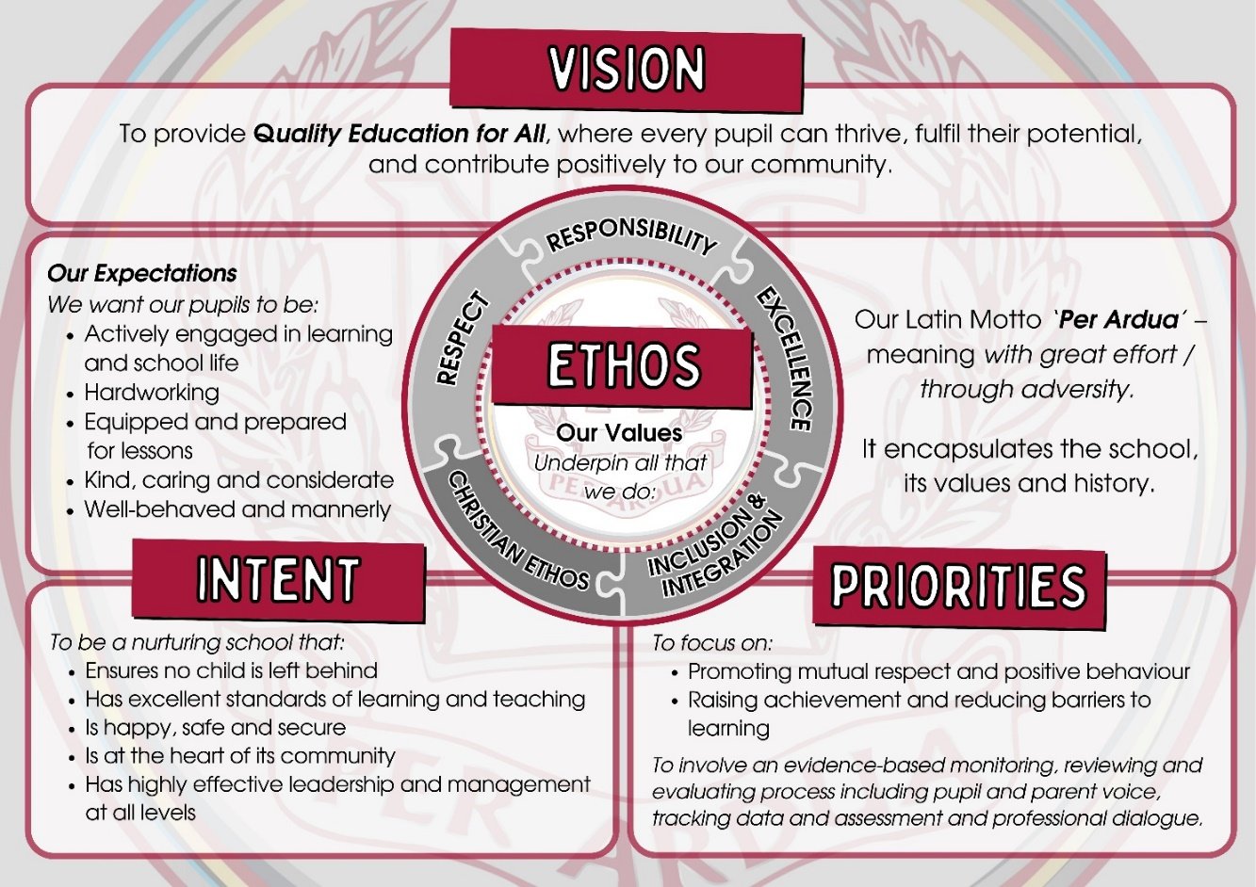

**RSE directives and legislation**

This policy responds to the guidance provided by DE, CCEA and DHSS, with the aim to encourage students to develop respect for themselves and others, to foster an understanding of healthy friendships and relationships and to develop responsible behaviour and the ability to make informed decisions within a social, moral, and spiritual framework.

The school’s RSE policy has been developed and guided by the following legislation. The Northern Ireland Council for Curriculum, Examinations & Assessment, (CCEA) issued guidance material on RSE in 2001. In response to this, the Department of Education issued circular 2001/15 RSE to support the guidance documentation. This circular stated:

*“The Department considers that every school should have a policy setting out how the school will address relationships and sexuality education within each student’s curriculum. The policy should be the subject of consultation with parents and should be endorsed by the school’s Board of Governors. All teachers, whether or not they are centrally involved in teaching the programme should be aware of its details and their implications”.*

The RSE policy attempts to deliver on the principles cited in the United Nations Convention on the Rights of the Child (UNCRC). The UNCRC articles cover all aspects of a child’s life, from the right to education, health and protection from abuse to the right to freedom of expression and access to information. It also says what governments and adults must do to ensure all children can enjoy all their rights. Articles 2 and 4 state that the convention applies to *“all children whatever their ethnicity, gender, religion language or ability”* and article 4 that *“every child has a right to express their views and have their view considered and taken seriously.”*

Since the revised Northern Ireland Curriculum was introduced, Relationships and Sexuality Education (RSE) has been a statutory component of the following key areas of learning:

* Personal Development and Home Economics statements of requirement for Learning for Life and Work at Key Stage 3; and
* Personal Development strand of Learning for Life and Work at Key Stage 4.

RSE is a lifelong process. It helps children and young people acquire knowledge, understanding and skills, and develop attitudes, beliefs and values about relationships, sexual identity, and intimacy. Effective RSE, which is taught in a sensitive and inclusive manner, encourages children and young people to value themselves as individuals and to make responsible and well-informed decisions about their lives. (ccea.org.uk)

**Definition of RSE**

We define RSE (within Global Citizenship) as being part of lifelong learning about the emotional, social and physical aspects of growing up, relationships, sex, human sexuality and sexual health. It aims to give students essential skills for building positive, enjoyable, respectful and non-exploitive relationships and to stay safe on and offline. It enables exploration of attitudes and values, helps build self-esteem and confidence to view their sexuality positively.

Relationship and Sex Education is not just learning about growing up, changes and reproduction. It is also about enabling children to make and maintain relationships with others, to understand sexuality and to feel good about themselves and the choices they make. This involves helping children to gain knowledge, develop skills and form positive beliefs and attitudes.

Relationships and Sexuality Education is a lifelong process, which encompasses the acquisition of knowledge, understanding and skills, and the development of attitudes, beliefs, morals and values about personal and social relationships and gender issues.

**Purpose of the Relationships and Sex Education Policy**

* Give information to staff, parents and carers, governors, students and outside visitors about the content, organisation, and approach to teaching RSE at Newry High School.
* Enable parents and carers to support their children in learning about RSE.
* Give a clear statement on what the school aims to achieve from RSE, the values underpinning it and why it is important for students.
* Set out how the school meets legal requirements in respect of RSE:
* Duty to promote well-being.
* Duty to prepare children for the challenges, opportunities and responsibilities of adult life.
* Ensure students learn about the nature of marriage and its importance for family life and bringing up of children.
* Protect students from unsuitable teaching and materials.
* Teach statutory RSE elements.
* Have an up-to-date policy developed in consultation with parents, staff and governors.
* Meet the school’s safeguarding obligations.
* Make the policy available to students and parents.
* Prevent discrimination, advance equality of opportunity and foster good relations between different groups.

1. **Aims of RSE Programme**

* Reinforce the core values of Newry High School
* Promote a pastoral programme within school that is woven through all aspects of school life.
* To develop positive, healthy responsible relationships in a moral, social and spiritual framework.
* To recognise and be aware of different forms of abuse and to develop skills to help keep themselves safe.
* To increase understanding among students of pertinent issues and give accurate information to help correct misunderstandings and help them make informed decisions and choices.
* To encourage an appreciation of the value of marriage, family life and other long-term relationships.
* To accept the characteristics of others and their own sexuality and to develop within students a respect for both their own and other people’s bodies.
* To prepare students to cope with the physical, social and emotional challenges of growing up and so help better prepare them for adult life.
* To provide students with the knowledge base needed to make informed decisions.
* To appreciate their parents/guardians and their role within the family and the
* responsibilities of parenthood.
* To have coping strategies to deal with relationships when they break down.
* To appreciate the value of human life.
* To encourage students to make informed decisions based on the information presented to them.
* Also, students who hold differing views are able to do so in an environment without threat.
* To ensure pupils at key stages 3 and 4 can ‘Receive age-appropriate, comprehensive and scientifically accurate education on sexual and reproductive health and rights, covering prevention of early pregnancy and access to abortion’ (Article 5(1A) education).

1. **Delivery of RSE**

RSE will be delivered through curricular progression in Personal Development, though aspects will also be taught in PSE, Science/Biology, Religious Education, Citizenship, Home Economics, LLW and through the school’s pastoral programme. These elements are outlined in the school’s curriculum mapping of all pastoral education across all subject areas.

Schools are required to deliver the statutory minimum curriculum content; however, the curriculum affords a large degree of flexibility to schools on how they develop and deliver the RSE taught programme. CCEA has produced separate specific guidance to support schools to plan and develop approaches to teaching controversial/sensitive issues at whole-school and classroom levels and this has been referenced in the revised RSE guidance. The RSE Progression Framework published by CCEA has also been used to develop appropriate programmes for each key stage.

The facilitation and delivery of the preventative curriculum is best taught by key adults that pupils already know, however, external speakers will also deliver elements of the RSE curriculum (E.g.- Love for Life and PSNI). The school recognises the expertise provided by individuals and those from statutory and voluntary organisations.

Before agreeing to use an external agency, teachers will:

* review resources that are to be used
* ensure they are satisfied with the quality of what is delivered by external providers.
* inform parents/guardians if applicable.
* ensure the input is in harmony with the school’s RSE programme.
* inform students of the purpose of the visit

A teacher will be present during all presentations. The school recognises the changing nature of society and the influence of the home on a child’s development, and lessons will be delivered in a sensitive and thoughtful manner. Should any student raise an issue that the teacher deems is beyond the level of maturity of the class, the teacher will arrange to speak to the child after class and may discuss the issue with the child’s parents/guardians and inform a member of the Safeguarding Team. The school’s child protection policy will be always adhered to.

It is important to acknowledge that there may be different thoughts and perspectives between students and their differing views need to be respected. While students will usually be taught in mixed groups, it may be necessary at times to deliver areas of the programme to males and females in single groups.

1. **Specific Issues**

The Status of the Family

The school promotes the value of long-term stable relationships including marriage, while acknowledging the diversity of family life that exists within society.

Confidentiality

Staff have a professional responsibility to share relevant information about the protection of children with other professionals, particularly investigative agencies and when physical or sexual abuse is suspected, a legal duty to report this. If a child confides in a member of staff and requests that the information be kept secret, it is important that the member of staff should tell the child, sensitively, that he or she has a responsibility to refer cases or alleged abuse to the appropriate agencies for the child’s own sake. Staff who receive information about children and their families in the course of their work should share their information only within appropriate professional contexts.

Safeguarding and Child Protection

Staff should be aware that students may be victims of abuse and it is accepted that it can be dealt with in two ways. Primarily to refer information that may arise to the Designated Teacher who will implement the school’s Safeguarding and Child Protection procedure. Secondly through the teaching of the preventative curriculum. Students may be supported through the promotion of self-esteem management of emotions and through skills of assertiveness.

Terminology

The use of proper terms for parts of the body and body functions will be used. It is very important proper terminology is used in class activities and that the tone of discussion is respectful and genuine.

The Value of Human Life

Students should acquire the knowledge to make sound value judgements on issues such as euthanasia and abortion in a non-judgemental and non-confrontational atmosphere. The input of all students is valued.

Sexual Identity and Orientation

*“All students have the right to learn in a safe, welcoming and inclusive environment, to be treated with respect and dignity and not to be treated any less favourably on grounds of their actual or perceived sexual orientation”* (Equality Commission).

All students will be valued and treated with respect regardless of sexual orientation, gender identity, religion, ethnicity etc. Staff should handle the issue of sexual orientation and gender in a sensitive non-confrontational and reassuring way. Teachers, whatever their personal views, will act to counteract prejudice and support the development of self-esteem and personal responsibility in all students. Students will be encouraged to show tolerance and respect to those who hold different values to their own. The school promotes equality for all students. Bullying on the grounds of sexual orientation, is as unacceptable as it is in any other situation, where someone is mistreated or bullied because of their differences from those who are perceived to be the majority. All issues relating to bullying on the grounds of sexual orientation or identification, or any other form of homophobic abuse will not be tolerated and will be dealt with in line with the school’s Anti-Bullying Policy.

Changes to statutory guidance (2023)

DE have recently asked schools to make the following amendments to their RSE education curriculum (DE circular 2024/1):

* The Relationships and Sexuality Education (Northern Ireland) (Amendment) Regulations (2023) amend the Education (Northern Ireland) Order 2006 and the Education (Curriculum Minimum Content) Order (Northern Ireland) 2007 in respect of Learning for Life and Work (LLW) to ensure that pupils at key stages 3 and 4 have the opportunity to *“Receive age appropriate, comprehensive and scientifically accurate education on sexual and reproductive health and rights, covering prevention of early pregnancy and access to abortion”* (referred to as “Article 5(1A) education”).

Withdrawal from class

At the request of a parent, a pupil at key stages 3 and 4 may excused from the new elements of RSE education, (Article 51A) or specified elements of that education. Under the Curriculum (Circumstances in which a Pupil may be Excused from Sexual and Reproductive Health and Rights Education) Regulations (Northern Ireland) 2023, a pupil may be excused if a parent makes a written request to school where the parent considers the education is against their wishes.

For pupils in Years 8,9, 10 and 11 where a parent makes a request for a pupil to be excused from Article 5(1A) education or specified elements of it by confirming which elements of the education, the pupil will be excused. For pupils in year 12 where a parent makes a request for a pupil to be excused from Article 5(1A) education or specified elements of it by confirming which elements of the education the pupil should be excused from and confirms that the pupil does not object to being excused.

All requests should be made in writing and addressed to the principal. The request should specify whether the request relates to all of Article 5(1A) education or specified elements. Parents are not required to provide a reason. A suggested template for use by parents is included in Appendix 1 of this policy. School may offer a meeting to discuss the request with parents and, as appropriate, with the pupil. This would ensure that the wishes of both the parent and child are understood. School will retain a record of the request. All excusals remain in force until the end of the academic year.

Staff

If a member of the teaching staff is uncomfortable teaching a certain part of the RSE curriculum, they should discuss the matter with the Vice-Principal

1. **Pastoral Support**

The school takes its role in the promotion of student welfare very seriously. Staff endeavour to provide caring and sensitive pastoral support and make themselves approachable for students. Newry High school is a nurturing school where teachers seek to build positive relationships with pupils and offer daily support.

School Engage and school counselling service within school are available to offer additional pastoral support for all students.

1. **Staff Training**

Newry High School is committed to the professional development of all its staff. Training needs will be considered and will be accessed using the EA, Public Health Agency and/or other appropriate health agencies. Where outside Agencies are used for training purposes, their remit will be clear and will reflect the ethos of the school.

1. **Related Documents**

CCEA Guidance for Post Primary Schools: Relationships and Sexuality Education

2015

* CCEA Personal Development NI Curriculum 2007
* CCEA post primary Guidance Material
* DHSS Sexual Health Promotion: Strategy and Action Plan 2008 – 2013
* DENI Circular 2010/01
* DENI Circular 2013/16
* DENI Circular 2015/22
* DENI Circular 2024/1
* Equality Commission’s Eliminating Sexual Orientation Discrimination in NI, March

2009

* Sexual Offences (NI) Order 2008 – Revised February 2009
* Supporting Trans Youth in Education. Youthnet, Genderjam and SailNI
* Guidance for Schools on Preventing and Responding to Sexist, Sexual and
* The Curriculum (Circumstances in which a Pupil may be Excused from Sexual and Reproductive Health and Rights Education) Regulations (Northern Ireland) 2023
* The Relationships and Sexuality Education (Northern Ireland) (Amendment) Regulations 2023.
* Transphobic Bullying. Department for Children, Schools and Families (DCSF)
* Information for parents and frequently asked questions regarding RSE is available on the DE website.

1. **Associated Policies**

* Addressing Bullying Policy
* E-Safety Policy
* Electronic Device Policy
* Promoting Positive Behaviour Policy
* Pastoral Care Policy
* Curriculum Policy
* Safeguarding and Child Protection Policy

1. **Review**

The Relationship and Sexuality Policy will be reviewed by all stakeholders and, if required, updated every three years in line with our school policy review cycle.

Contents of this policy have been developed in consultation with the BOG, parents/carers, staff and students of Newry High School.

|  |  |  |
| --- | --- | --- |
| **Stakeholder** | **Date** | **Method** |
| **BOG** | September 2024 | BOG meeting (September and October 2024) |
| **Staff** | November 2024 | November 2024- email sent out to staff for consultation |
| **Parents** | November 2024 | November 2024- email sent out to parents for consultation |

**Ratified by the Newry High School Governing Board of Governors:**

**To be reviewed: December 2027**

1. **Signatures of Key Individuals**

|  |  |  |  |
| --- | --- | --- | --- |
| **Person** | **Position** | **Signature** | **Date** |
| **Mr Colin Whiteside** | **Chairperson of the BOG** |  |  |
| **Mr Iestyn Brown** | **Principal** |  |  |
| **Mr Craig McKee** | **Vice-Principal** |  |  |

**Appendix 1**

**PROPOSED TEMPLATE FOR USE BY A PARENT / GURADIAN / CARER REQUESTING THAT A PUPIL BE EXCUSED FROM ARTICLE 5(1A) EDUCATION OR A SPECIFIED ELEMENT OF IT.**

**For pupil in Year 8-11**

To the Principal of Newry High School regarding:

Pupil Name- ___________________

Class: ______________

I am writing to request that my son/daughter (Name) who is a pupil in Year x at your school be excused from age-appropriate, comprehensive, or scientifically accurate education on sexual and reproductive health and rights, covering prevention of early pregnancy and access to abortion or the specified element or elements of it as set out below. I can confirm that this education is contrary to my wishes.

Please tick as appropriate

* Prevention of early pregnancy ____
* Access to abortion ___

(Name of parent / guardian / carer)

(Date)

**For pupil in Year 12**

To the Principal of Newry High School regarding:

Pupil Name- ___________________

Class: ______________

I am writing to request that my son/daughter (Name) who is a pupil in Year 12 at your school be excused from age-appropriate, comprehensive or scientifically accurate education on sexual and reproductive health and rights, covering prevention of early pregnancy and access to abortion or the specified element or elements of it as set out below. I can confirm that this education is contrary to my wishes. I can confirm that (Name of pupil) has not objected to being excused.

Please tick as appropriate

* Prevention of early pregnancy ____
* Access to abortion ____

(Name of parent / guardian / carer)

(Date)