#### SCHOOL DRESS CODE AND UNIFORM POLICY

#### 2024-2025

**Context**

School uniform is a fundamental aspect of our identity at Newry High School, we aim to reinforce a sense of pride among our students both in school and when representing the school in the wider community. We expect our parents or guardians to cooperate fully with our school dress code, as this is an essential aspect of school discipline. All students should attend school correctly dressed in a clean well-kept manner. Students will be sanctioned if they are not adhering to our school dress code and non-uniform items may be confiscated.

**Uniform**

**Compulsory items:**

* Newry High School blazer complete with integral pocket badge
* A white long or short sleeve shirt/blouse, buttoning at the neck. It should be tucked into trouser/skirt at all times.
* Black Newry High School regulation trousers – full length and regular fit or black Newry High School regulation skirt - double pleated knee length skirt (worn to the top of the kneecap)
* Black socks, or with the skirt - black tights (not less than 40 denier) or knee-high black socks
* Newry High School clip-on tie relevant to the year group in which the student attends
* Plain black leather or leather-look shoes suitable for cold and wet weather
* Year 8-10-Junior tie Years 11-14-Senior tie Year 14 prefect’s tie

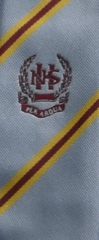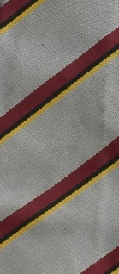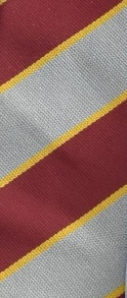

**Optional:**

* A maroon Newry High School pullover with a double grey stripe on the 'V' neck.
* Black Newry High School regulation hoody. This may be worn under the blazer during inclement weather (1st October to 31st March)
* Belts (if worn) should be plain black with plain buckles
* Black school coat complete with integral school crest
* School scarf
* School bobble / beanie hat

**Please note the following do not conform to the school regulations and must not be worn in school:**

* Skinny or slim fit trousers ;
* ‘Jean’ like trousers / skinny jeans;
* Pullovers / hooded tops / hoodies / scarves / bobble hats apart from school regulation pullover, hoody, scarf and bobble hat

**Examples of acceptable shoes -** shoes should not have heels more than 5cm

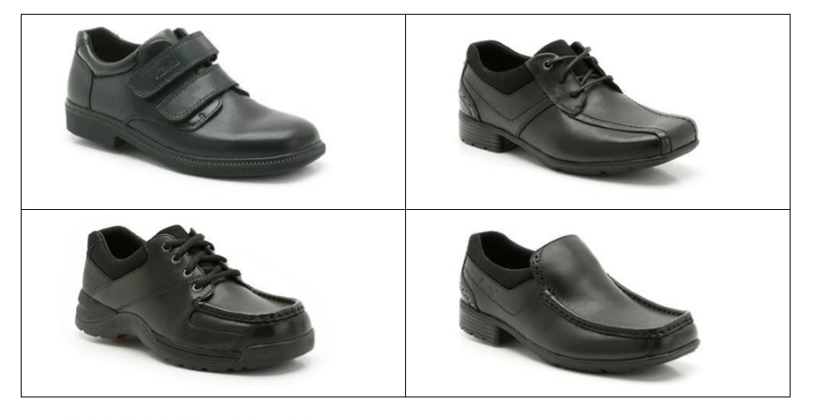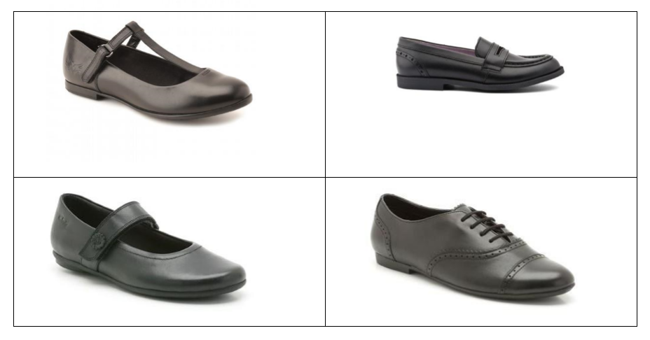

**Please note: the following do not conform to school regulations regarding shoes and must not be purchased to be worn with school uniform:**

* Trainers or trainer type shoes;
* Shoes with white or coloured soles / rims;
* Platform shoes, shoes with stiletto, kitten or narrow wedge heels;
* Shoes with decorative additions/tassels;
* Suede, canvas, ballet style pumps or other textile shoes;
* Boots/fashion footwear above the ankle

Parents of students whose shoes do not conform to school regulations will be asked to purchase new shoes immediately.

**Physical Education Uniform**

Our PE uniform reflect the values and ethos of the Physical Education Department. A high standard of dress promotes the development of PE and sport within Newry High School and has a positive effect on teaching and learning, whilst promoting a positive sporting image.

**Compulsory:**

* School PE t-shirt
* School PE shorts/school PE skort *These items can be purchased from our uniform suppliers*
* School PE sports socks
* Suitable supportive sports trainers
* Shin pads for hockey and football

We highly recommend the use of a gum shield/mouth guard for hockey and contacts sports during PE lessons. Shin pads and gum shield/mouth guards are compulsory for all extra-curricular activities.

**Optional:**

* School hoody complete with integral school crest (*available to purchase in school*)
* School quarter zip jumper
* School tracksuit bottoms
* School leggings

Please note that students are not permitted to participate in PE with body piercings. All piercings must be removed as a matter of health and safety.

Aerosol deodorants are not permitted in the PE changing rooms owing to the adverse effects that these can have on students with asthma and other associated breathing conditions.

**Technology & Design and Home Economics**

A plain coloured apron with large pocket is required for Technology and Design. A large plastic container with a secure lid, is also required for Home Economics.

**Hairstyle**

Hairstyles should be simple and of a natural colour. Extreme hairstyles, such as shaven heads or patterns are not permitted. If you are unsure, please contact the school for clarification. The final decision lies with the Principal, Vice Principal or Senior Teacher.

Shaved or patterned eyebrows are not permitted.

Facial Hair: Pupils in years 8 to 12 must be clean shaven at all times. We do not enter into discussion on this point. Pupils in Year 13 and Year 14 are permitted facial hair, however, it must be kept neat, tidy and well-groomed at all times.

**Make-Up**

Students may wear discreet (light) foundation to match their natural skin tone. Heavy make-up is not acceptable. Eyeshadow, heavy dark eyeliner, thick block eyebrow pencil, mascara, false eyelashes or brightly coloured lipstick are not permitted to be worn at any time during the school day.

Nails may *only* bepainted with clear or ‘French’ manicure polish. Health & Safety considerations dictate that nails must be kept short. False nails or nail art are not permitted.

**Jewellery**

Pupils are permitted to wear one small stud / sleeper in each ear. No other piercings are permitted. Pupils will be required to remove any other facial piercing e.g. additional ear piercings, hoops, nose, eyebrow etc

Visible tattoos are not permitted. Tattoos for those students legally able to have one, must always be kept covered.

**Consequences and additional guidance**

**Complete school uniform must be worn to school each day**. Students are required to comply with the current regulations, which will be strictly enforced. Uniform is expensive, but it is sensible and practical and, with care, can be made to last for some time. Parents/carers are urged not to incur extra and unnecessary expense by purchasing items that do not meet the school’s requirements.

We expect our students to take responsibility for and have pride in their appearance. **Students who fail to conform with our dress code and uniform requirements will receive consequences in line with our Positive Behaviour Policy**. Consequences may include not being able represent the school in events, detention, being out of circulation at break and lunchtime, Supervised Support or suspension. If incorrect uniform is worn it may be confiscated and a parent/carer will be expected to collect the item from school.

Students may be asked to exchange their electronic device for a temporary replacement uniform item, for example a school tie. The device will then be returned to the student only when the borrowed item is returned. We believe this supports student understanding of respect and responsibility.

**Financial assistance**

For your information, financial assistance is available through the Education Authority’s Clothing Allowance Scheme for some pupils towards the cost of school uniforms. The eligibility criteria are the same as those used for free school meals. Parents / carers who require more information please go to the EA’s website [www.eani.org.uk](http://www.eani.org.uk) or follow the link below. The information and application forms are available in a number of different languages for parents whose first language is not English.

<https://www.eani.org.uk/financial-help/free-school-meals-uniform-grants>

**Availability**

The official suppliers for our uniform are:

1. Daisy, Hill Street, Newry
2. McEvoy’s, Monaghan Street, Newry
3. W Moorehead, 23 Fountain Street, Bessbrook, Newry
4. Saints & Scholars, 23 Mill Street, Newry

**It is essential that all items of clothing and equipment are clearly labelled with the students name and Tutor group. *If you are in any doubt about the interpretation of the regulations, please consult the school before buying new clothes or footwear.***